Modeling and Measuring Ecosystem Biodiversity
AP Biology

OBJECTIVES: After you complete this activity you will be able to
- Describe the structure of a community according to its species composition and diversity
- Use the Simpson Diversity Index to determine the degree of species composition and diversity
- Describe the relationship between ecosystem diversity and its resilience to changes in the environment
- Explain how the addition or removal of any component of an ecosystem will affect its overall short-term and long-term structure

INTRODUCTION
Did you ever wonder why some environments had dozens of different organisms that lived there, while others seemed to be inhabited by only a few kinds of organisms? The biodiversity of an ecosystem acts as an indicator of overall ecosystem health, and can tell you a lot about that ecosystem. There are several different methods that can be employed to measure ecosystem biodiversity. One such measure is the Simpson’s Diversity Index.

Biodiversity will increase naturally as succession occurs in an ecosystem--as an ecosystem ages and reaches its climax community, the number of species occupying various niches increases which can act as an indicator of ecosystem stability. There are two factors that comprise biodiversity: species richness and species evenness. Species richness refers to the number of varied species that occupy an ecosystem, while species evenness refers to the number of each species that occupies an ecosystem. The diagram below provides a visual explanation for these concepts:
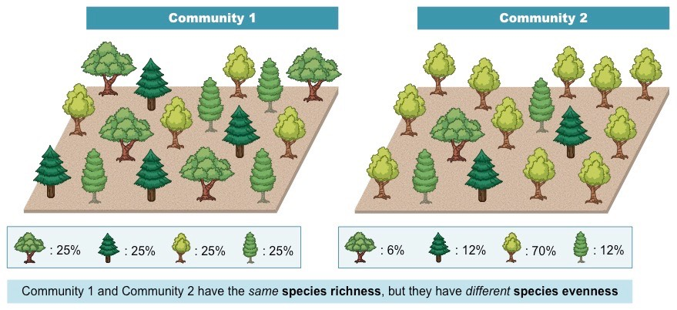
Image source: https://ib.bioninja.com.au/_Media/biodiversity_med.jpeg

Ecosystems such as old-growth forests and rainforests tend to be quite complex in their biodiversity and are stable. However, not all ecosystems have the same level of biodiversity. Humans have altered many ecosystems to reduce their complexity and diversity by converting previously unused forests into cropland, for example. The conversion of forests into croplands reduces biodiversity by creating monocultures (all the same species), which presents several problems. Nature’s tendency to increase biodiversity through succession is something humans battle in an attempt to maintain these monocultures. This is often done with the use of pesticides and herbicides which kill off undesirable species, but that also tend to create other problems when these substances are used to make it easy to harvest a crop for human use.

The Simpson’s Diversity Index is used to determine how biodiverse an area is. The formula we will use looks like this:
$Diversity Index = 1-Σ{\left(\frac{n}{N}\right)}^{2}$ | Where n = the total number of organisms of a particular species  N = total number of organisms of all species

The index has values of 0 to 1. A large index value indicates a higher degree of biodiversity and a stable ecosystem with many niches and little competition, while a lower value indicates a lower degree of biodiversity which may indicate an ecosystem with a few dominant species and a greater degree of competition.

In this activity, you’ll determine the Simpson’s Diversity Index for a model ecosystem, and then compare it to others in the class. You’ll then be asked to consider factors that might contribute to the index value for your particular ecosystem, and why. Finally, as a class, you’ll use the index value you calculate for each of the ecosystems you analyze to determine which ecosystems are worth rescuing from disaster or human intervention.

MATERIALS
Computer with web access | Graph paper or graphing software | Calculator | Patience for virtual counter 😊

PROCEDURE
- Go to http://virtualbiologylab.org/NetWebHTML_FilesJan2016/StreamDiversityModel.html
- Set up and Collect Data Set #1.
  - Set Pollution to: None
  - Click “Open Seine”. A Seine is a vertically hanging net.
  - Click “Go”.
  - Record Data in Table 1.
- Set up and Collect Data Set #2.
  - Set Pollution to: Moderate.
  - Click “Open Seine”.
  - Click “Go”.
  - Record Data in Table 1.
- Set up and Collect Data Set #3.
  - Set Pollution to: Severe.
  - Click “Open Seine”.
  - Click “Go”.
  - Record Data in Table 1.

DATA
Fill in the Table 1 with your data collected from the virtual simulation.

 | None | Moderate | Severe
Caddisfly
Dragonfly
Mayfly
Crayfish
Stonefly
Sowbug
Rif Beetle
Worm
W. Penny
Black Fly
Gill Snail
Midge
Dobsonfly
Leech
Cranefly
Lung Snail
Table 1: Data Collection from stream

ANALYSIS
Now that you’ve collected data about your experiment, use the Simpson’s Diversity Index to determine the effect of pollution on the level of biodiversity. Remember the formula is:

$Diversity Index = 1-Σ{\left(\frac{n}{N}\right)}^{2}$
Once you have calculated the diversity index for your ecosystem, compare your value to the others in class. Record that information here:

Pollution Level | Simpson’s Diversity Index | Species Richness
None
Moderate
Severe

Use this information to produce a graph comparing the biodiversity indices of the stream with varying levels of pollution. Which level of pollution would you invest time and resources into restoring, and why?

QUESTIONS
- When you compared the biodiversity indices to one another, what did you notice?

- When you compared the species riches to one another, what did you notice?

- How does pollution affect the species richness and biodiversity of the stream?

- Describe how human intervention can change biodiversity in positive ways.

